Internal and forced interdecadal variations of global sea surface temperature
in recent warming era

Dong-Ping Wang^{1,2}, Dake Chen^{2,3}, Minghua Zhang²

email: dong-ping.wang@stonybrook.edu

¹ State Key Laboratory of Satellite Ocean Environmental Dynamics, Second Institute of Oceanography, Hangzhou, China
² School of Marine and Atmospheric Sciences, Stony Brook University, Stony Brook, New York, USA
3 Lamont-Doherty Earth Observatory, Columbia University, Palisades, New York, USA
Abstract
The nonseasonal sea surface temperature (SST) since the mid-twentieth century is examined with extended empirical orthogonal function (EEOF) analysis in a single global domain with no prior filtering to investigate the roles of forced and natural modes of variability in the observed climate. The global SST variability is described by the El Nino - Southern Oscillation (ENSO) modes, the interdecadal oscillation mode, and a secular mode with long-term trends. The interdecadal SST variability is associated with a regime shift of the ENSO modes, an internal oscillation and a secular trend. The internal interdecadal oscillation shows the classical Atlantic Multidecadal Oscillation (AMO) accompanied with covarying SST anomalies in the extratropical North Pacific. The secular mode shows large spatial variations, marked by a widespread warming in the western Pacific and the North Atlantic but a cooling in the eastern equatorial Pacific. The secure mode accounts for about 70% of the global warming trend in the recent warming era. The study suggests the possibility that the recent cooling trend in the eastern Pacific is likely externally forced, as opposed to the prevailing view of it as an internal cycle of the Pacific interdecadal variability.
1. Introduction
The global sea surface temperatures (SST) have large spatial and temporal variability (for a review, see Deser et al. 2010). On the interannual time scale, El Nino - Southern Oscillation (ENSO) is the dominant mode of global SST variability. For the interdecadal time scale, the Pacific Decadal Oscillation (PDO) and Atlantic Multidecadal Oscillation (AMO) are the two principal basin-scale oscillations. Over a still longer time scale, the global mean temperature has risen steadily, which is attributed to external (anthropogenic) forcing of greenhouse gases. A major goal in climate diagnostics is to isolate the externally forced response in the presence of a large internal (natural) interdecadal variability (Thompson et al. 2009). The task can be quite daunting. For example, since the turn of the century the global warming trend has stalled unexpectedly. The warming 'hiatus' is thought to be triggered by a persistent cooling in the eastern equatorial Pacific (Kosa and Xie 2013; England et al. 2013). However, whether the cooling trend is part of a natural interdecadal cycle or is itself externally forced is not clear (Held 2013).
The empirical orthogonal function analysis (EOF) and its variations, which attempt to extract the largest spatio-temporal covariance of a data matrix, are commonly used to identify the dominant patterns of global SST variability. ENSO is the leading EOF mode of detrended SST anomalies over the global ocean, and PDO and AMO are respectively the leading EOF modes of the North Pacific (20ºN - 70ºN) and the North Atlantic SST anomalies, after removing the global mean (Enfield et al. 2001; Ting et al. 2009; Deser et al. 2010). In analysis of the century long SST record, a secular trend often is removed. This is to minimize the impact of a strong warming trend in the early twentieth century which otherwise might compromise the integrity of the leading EOF modes (Zhang et al. 1997). The assumption of a homogeneous secular trend however cannot be justified (Guan and Nigam 2008; Messie and Chavez 2011).
In this study, we apply extended EOF (EEOF) analysis to global SST data with no prior detrending. Our analysis is limited to the post-1950 period, thus mainly dealing with the recent warming era which started in the mid-1970s. We note that the spatial pattern of the warming trend in the early twentieth century differs substantially from that of the recent era. Whether this is indicative of a changing climate or is an artifact of limited data coverage in the early period is not clear. As EOF assumes a stationary spatial pattern, restricting analysis period to a single warming era seems prudent. We find that the global interdecadal variability since the mid-twentieth century is mainly contributed by a regime shift of ENSO, an interdecadal covarying SST variability in the North Atlantic and North Pacific, and a secular trend. We also show that the interdecadal SST variability is clearly reflected in the corresponding sea level pressure (SLP) variations. The rest of the paper is organized as follows. Section 2 outlines the data and EEOF method, section 3 describes the global SST pattern, global mean temperature, and global SLP pattern, and section 4 discusses some key implications.
2. Data and Methods
a. Data
The gridded SST reanalysis is from the monthly UK Met Office Hadley Centre's sea ice and sea surface temperature dataset, HadISST, a 1º × 1º high-resolution SST dataset reconstructed from in situ and satellite observations (Rayner et al. 2003). The study period is from 1950 to the present. Seasonal means are computed from monthly data, and SST anomalies are formed by removing the seasonal cycle, the mean of each season. The gridded SSTs are area weighted by the square root of the cosine of latitude (North et al. 1982). The analysis is over the globe between 70ºS and 70ºN, retaining the original 1º data resolution. The gridded atmospheric reanalysis is from the monthly National Centers for Environmental Prediction/National Center for Atmospheric Research (NCEP/NCAR) Reanalysis for sea level pressure (SLP) and surface wind (Kalnay et al. 1996). The horizontal resolution is 2.5º × 2.5º, and the data is from 1948 to the present.
b. Methods
An extended empirical orthogonal function analysis (EEOF) is used in this study. EEOF is the same as EOF or the Principal Component Analysis, except that the original and its time-lagged fields are concatenated to form an extended dataset. This allows spatial patterns to evolve to capture the spatio-temporal variations. We use a sliding window of 5 seasons. Our analysis method is similar to Guan and Nigum (2008, 2009). The extended dataset is large, 252 seasons of 360 (longitudes) × 180 (latitudes) × 5 (lags) pixels each. For computational efficiency, a two-dimensional PCA, the Generalized Low Rank Approximation of Matrices (GLRAM), is adopted in this study (Ye 2005).
3. Results
a. Global patterns
The first 5 EEOF modes explain 19.2, 13.5, 7.6, 4.5, and 3.9% of total variance respectively. The EEOF modes are well separated according to North et al. (1982). Figure 1 shows the principal components (PCs) together with Nino-3.4. The Nino-3.4 index is the area averaged SST anomaly in the central-eastern tropical Pacific (5ºN-5ºS, 170º-120ºW); for consistency, Nino-3.4 is smoothed over 5 seasons. It is seen that the time series of PC1 is well correlated with the Nino-3.4 index. It displays a regime shift in the 1970s. PC2 on the other hand has a secular trend, while PC4 has a clear interdecadal oscillation. PC3 and PC5 display large interannual variations that will be shown to correspond to ENSO modes.
Figures 2 show the corresponding base functions of the three primary modes: the first, second, and fourth modes, and Fig. 3 the secondary modes: the third and fifth modes. Figure 4 shows the averaged spatial patterns of the three primary modes, mean over the five seasons; the sign of the first mode is reversed to show the cold phase. We note that the averaged spatial patterns agree well with those derived from the EOF analysis.
The first mode is a global manifestation of the canonical ENSO. The base function describes the warm phase (El Nino), marked by a large warming in the central-eastern tropical Pacific and along the coasts of North and South America, a cooling in the extratropical North Pacific, and a warming in the tropical Indian and Atlantic Oceans. The evolution of El Nino is clearly displayed in the 5-season EEOF pattern. The warm event starts in spring (year 0) (top panel, Fig. 2a), reaches its peak in fall and winter, and diminishes in the following spring (year 1). The first principal component (PC1) mirrors Nino-3.4. However, PC1 has an abrupt baseline shift around 1976/1977, which has no counterpart in Nino-3.4. The sudden warming corresponds to the well documented 'regime shift' in the North Pacific (Mantua et al. 1997).
The second mode shows a strong cooling in the eastern tropical Pacific in a narrow strip between 5ºS-5ºN, a widespread warming spanning symmetrically from the western tropical Pacific to the extratropical North and South Pacific, and a broad warming in the Atlantic and the Indian Ocean. The pattern is similar to ENSO but with some notable differences. In La Nina, the cold tongue in the eastern equatorial Pacific is broader, but the SST anomalies in the western tropical Pacific and extratropical South Pacific are negligible (Fig. 4). The second principal component (PC2) moreover is quite different from Nino-3.4. PC2 has a clear secular trend: it is quiescent prior to the regime shift but rises rapidly afterwards. In other words, the North Atlantic and Indian Oceans are becoming warmer in recent decades while the eastern equatorial Pacific is becoming cooler. A warmer Indian Ocean is believed to be responsible for apparent changes in relationship between ENSO and rainfall in Australia since the early 1970s (Nicholls et al. 1996).
The fourth mode is characterized by a broad zonal band of warm anomalies in the extratropical North Pacific (~ 40ºN), warm anomalies at the equator near the dateline, and a broad warming in the North Atlantic. The spatial pattern in the North Atlantic, with strong positive SST anomalies in the subtropics and south of Greenland, can be identified to AMO. The fourth principal component (PC4) also matches with the AMO sequence of warm phases through the end of the 1960s and since the beginning of the 2000s and a cold phase in between (Deser et al. 2010; also see Fig. 5b). The SST anomalies in the North Pacific, on the other hand, is usually attributed to PDO, despite the obvious covarying pattern with AMO since the mid-twentieth century. We note that the covarying North Atlantic and North Pacific SST is found in the internal multidecadal component of several climate simulations (DelSole et al. 2011). Impact of AMO on the North Pacific SST is also demonstrated in a controlled climate model experiment (Zhang and Delworth 2007).
The third and fifth modes are confined to the Pacific (Fig. 3) and are of interannual time scales (Fig. 1). In other words, they are ENSO variations. They have previously been identified with a biennial and a non-canonical mode respectively in an EEOF analysis of the Pacific SST variability (Guan and Nigam 2008). The biennial mode has a characteristic ENSO pattern of strong SST anomalies in the central-eastern equatorial Pacific. However, unlike the canonical mode, the anomalies switch sign in less than 3 seasons, corresponding to a 2-year cycle (Rasmusson et al. 1990). The non-canonical mode has a strong meridional temperature gradient near the Inter-tropical Convergence Zone (ITCZ), and is closely related to the Pacific meridional mode (Chiang and Vimont 2004).
b. Global mean temperature
The first two EEOF modes explain about 33% of global SST variance in total, yet they account for 65.7 and 28.1% of the variance of the global mean SST, respectively; the area average is weighted by the cosine of latitude. In other words, practically all of the global mean SST can be explained by the two largest spatially coherent patterns. Figure 5a shows global mean SST and global mean of the second mode; the first mode is nearly equal to the difference between the two time series (γ = 0.96) (not shown). The global mean SST shows a quiescent period before the regime shift of 1976/1977, a period of rapid warming afterwards, and a warming hiatus since 2000. The secular mode follows the same general trend. Though, after subtracting of the first mode, ENSO variability is significantly reduced, the regime shift is removed, and the hiatus is not as prominent. We calculate the linear trend for the current warming era (1977 - present). For the (5-season averaged) global mean SST, the linear trend is 0.082 ± 0.011 ºC per decade (95% confidence interval). The secular trend accounts for almost 70% of the global temperature rise in this period, 0.056 ± 0.009 ºC per decade, indicating that it is very likely forced by greenhouse warming.
The North Atlantic (0ºN - 70ºN) mean SST is dominated by the second and fourth modes, which contribute 38.6 and 35.8 % of total variance respectively. The second mode is responsible for the secular trend, whereas the fourth mode is responsible for the interdecadal oscillation. Figure 5b shows the (5-season averaged) AMO index and the North Atlantic mean of the internal mode; recall that the AMO index is the North Atlantic mean SST minus the global mean. The two time series have nearly identical interdecadal variations, which reinforces the earlier assertion that the internal mode is basically the AMO. The linear trend (1977 - present) for the North Atlantic mean SST is 0.206 ± 0.021 per decade (95% confidence interval), about 2.5 times of the global mean. About half of the North Atlantic warming is associated with the secular trend, 0.102 ± 0.016 ºC per decade, and the other half with the internal mode, 0.098 ± 0.012 ºC per decade. We note that the spatial patterns in the North Atlantic are substantially different between the internal mode and secular trend (Fig. 4). For example, off the east coast of the U.S., the secular trend shows a strong positive SST anomaly whereas the internal mode has a weak negative SST anomaly. Conversely, the internal mode has much stronger SST anomalies south of Greenland.
The North Pacific (20ºN - 70ºN) mean SST is also dominated by the second and fourth modes, which contribute 27.1 and 30.2 % of total variance respectively. The interdecadal variability in the North Pacific commonly is described by the PDO index, which is the leading EOF mode of SST anomalies after removing the global mean, over the North Pacific (20ºN - 70ºN). To compare with PDO, we construct a North Pacific (NP) index as the sum of the second and fourth modes, averaged over the same North Pacific domain, minus the global mean. Figure 5c shows the PDO index and the NP index (the sign of PDO index is reversed). The two time series agree rather well. In particular, the well-publicized PDO phase changes in 1976/1977 and 1999/2000 are well reproduced by the NP index.
c. Global sea level pressure
Figure 6 shows regression patterns of (5-season averaged) sea level pressure (SLP) anomalies with the first, second, and fourth modes. The region south of 30ºS is excluded to avoid off-scale amplitudes over the Southern Ocean. For the canonical ENSO mode, the tropical Pacific SLP shows the classical Southern Oscillation (SO) pattern with positive SLP anomalies west of the dateline and negative anomalies to the east during El Nino. In addition, there is a strong negative SLP anomaly in the extratropical North Pacific, corresponding to a deeper Aleutian low over the Gulf of Alaska (Alexander et al. 2002). For the secular trend, there is also a see-saw pattern of reversing SLP between the eastern and western tropical Pacific and a large SLP anomaly in the extratropics (the sign is reversed from the first mode). However, the SLP anomalies over the Gulf of Alaska are not as intense as in ENSO, and consequently, the meridional SLP gradient across the equatorial Pacific is much weaker. In fact, there is a secondary SLP maximum at the equator near 160ºW, which coincides with the center of negative SST anomalies in the secular trend (Fig. 4b).
The SLP pattern of the interdecadal mode is dominated by a low pressure center in the subtropical North Atlantic, a high pressure center over the Greenland, and another positive center in the Gulf of Alaska. The AMO is thought to be associated with the Atlantic meridional overturning circulation (MOC) (Delworth and Mann 2000). When the MOC is strengthened during the warm phase of AMO, the northward atmospheric heat transport presumably is reduced, leading to a weakening of the Aleutian low through atmospheric teleconnections (Zhang and Delworth 2007). A positive SLP anomaly in the Gulf of Alaska reduces the surface heat flux and Ekman heat transport, which could account for the extratropical warm anomalies (Alexander et al. 2002). The SLP pattern in the North Atlantic, on the other hand, is comparable to the North Atlantic Oscillation (NAO) (Hurrell 1995). A warm AMO phase corresponds to a low NAO index, which is also consistent with surface forcing of warm anomalies. However, previous studies do not support direct atmospheric forcing of the AMO (Kushnir 1994; Dima and Lohmann 2007) (also see Discussion).
Zhang et al. (1997) compared the interdecadal differences of mean SST, SLP and surface winds between 1950-1976 and 1977-1993. Trenberth and Fasullo (2013) made a similar comparison between 1979-1998 and 1999-2012. These three epochs correspond respectively to the negative, positive, and negative phases of PDO (the sign is reversed, Fig. 4c). It is argued that the epoch differences mainly reflect the PDO phase change. We update the calculations for the same three epochs, 1950-1977 (E1), 1977-1999 (E2), and 1999-2013 (E3). Figure 7 shows epoch differences for SLP; the corresponding wind and SST patterns can be found in the above references. Superficially the two difference maps are similar, as both are marked by strong positive SLP anomalies over the Gulf of Alaska. However, compared with SLP regression patterns (Fig. 6), E2-E1 is much closer to the canonical ENSO mode (the sign is reversed) while E3-E2 resembles the secular trend. As originally noted in Zhang et al. (1997), the epoch difference between E1 and E2 is due to the regime shift (Fig. 1b), and its SLP pattern is 'ENSO-like'. The epoch difference between E2 and E3, on the other hand, is mainly associated with the secular trend (Fig. 1c). The corresponding SLP pattern of a weak meridional gradient across the equator, is clearly distinguished from E1-E2. We note that the recent SLP trend is much similar to E3-E2 than E1-E2 (England et al. 2013).
4. Discussion
In this study, we show that the observed interdecadal SST variability since the mid-twentieth century is associated with a regime shift in 1976/1977 (first mode), an interdecadal covarying SST between the North Atlantic and North Pacific (fourth mode), and a secular trend (second mode). Our analysis differs from most previous studies in that we have retained a global secular trend. Detrending, which is a common practice in global analysis, assumes that the secular trend is more-or-less spatially homogeneous. Our study indicates the contrary that the secular trend has large spatial variations with a sign reversal in the eastern Pacific (Fig. 4b). Since detrending does a poor job of removing the trend, it in effect introduces significant noise into the EOF calculation.
The secular trend likely is driven by anthropogenic forcing associated with greenhouse gases. This gives an alternative to the prevailing view on the recent cooling in the east equatorial Pacific that attributes it to interdecadal oscillations. It may seem counterintuitive that a uniform radiative heating could induce cooling in the eastern equatorial Pacific, but strong feedbacks between the tropical ocean and the atmosphere can cause responses with spatial variations. One such mechanism is an ocean dynamical thermostat (Clement et al. 1996; Cane et al. 1997). In the equatorial Pacific, the thermocline shoals eastward. Because of a shallow thermocline, surface warming in the east is offset by upwelling of cold subsurface water, causing a smaller temperature increase relative to that in the west of a deep thermocline. Through the Bjerknes feedback, the east-west SST gradient is reinforced, which eventually leads to a cooling in the eastern equatorial Pacific. We note that the atmospheric processes associated with radiative heating are not considered in the model of ocean thermostat. For example, in a warming climate the Walker Circulation is expected to become weakened, which would oppose the ocean thermostat (Held and Soden 2006; DiNezio et al. 2013).
A delayed response to the high NAO index has been suggested for the AMO phase change since the mid-1990s (Robson et al. 2012; Msadek et al. 2014). A sustained negative AMO from the early 1970s to the mid-1990s (Fig. 5b) corresponds to a negative SLP anomaly or a deeper low pressure over the Greenland. This enhances surface cooling, which leads to increased deep water formation and a larger overturning circulation. A strengthened MOC, on the other hand, causes an increased poleward surface heat transport, which counters surface cooling and drives AMO towards a positive (warm) phase. Since the mid-1990s, however, the North Atlantic is under a sustained positive SLP anomaly. The same mechanism presumably will drive a reverse cycle in the absence of external influence.
In our analysis, the decade-long cooling of the eastern equatorial Pacific, which is believed to be responsible for the recent global warming hiatus, is attributed to an externally forced secular trend. The observed SLP trend is also consistent with a secular SST trend. The current paradigm however has focused on a cold PDO phase. Whether a cooler eastern equatorial Pacific is externally forced or is due to a Pacific internal oscillation will have important implications for climate forecast (Kosaka and Xie, 2013; England et al. 2013). It is though important to remind that the objective analysis is severely constrained by a relatively short instrument record and the likelihood of a changing climate. A process based study is needed to verify if an empirical mode is genuine or not, and to elucidate the dynamical response of the tropical Pacific Ocean to global warming (Clement and DiNezio 2014).

Acknowledgements
DC is supported by grants from National Key Basic Research Program of China (2013CB430302), National Natural Science Foundation of China (91128204), and the Office of Naval Research (N00014-12-1-0911). MZ is supported by the National Science Foundation and the Office of Biological and Environmental Research of the Department of Energy.

References
Alexander, M. A. and Coauthors, 2002: The Atmospheric Bridge: The influence of ENSO teleconnections on air-sea interaction over the global oceans. J. Climate, 15, 2205-2231.
Clement, A. C., R. Seager, M. A. Cane, and S. E. Zebiak. 1996: An ocean dynamical thermostat. J. Climate, 9, 2190–2196.
Cane, M. A. and Coauthors, 1997: Twentieth century sea surface temperature trends. Science
275, 957-960 .
Clement, A., and P. DiNezio. 2014: The tropical Pacific Ocean - back in the driver's seat? Science, 343, 976-978.
Delsole, T., M.K. Tippett, and J. Shukla. 2011: A significant component of unforced multidecadal variability in the recent acceleration of global warming. J. Climate,. 24, 909–926.
Delworth T, Mann M. E., 2000: Observed and simulated multidecadal variability in the Northern Hemisphere. Climate Dyn. 16:661–76
Deser C, Phillips AS, Hurrell JW. 2004. Pacific interdecadal climate variability: linkages between the tropics and the North Pacific during boreal winter since 1900. J. Climate 17, 3109–3124.
Deser, C., M. A. Alexander, S.-P. Xie, and A. S. Phillips, 2010: Sea surface temperature variability: Patterns and mechanisms. Annu. Rev. Mar. Sci., 2, 115–143.
DiNezio, P.N., G.A. Vecchi, and A.C. Clement, 2013: Detectability of changes in the Walker circulation in response to global warming. J. Climate, 4038-4048.
Enfield, D. B., A. M. Mestas-Nunez, and P. J. Trimble, 2001: The Atlantic multidecadal oscillation and its relation to rainfall and river flows in the continental U.S. Geophys. Res. Lett., 28, 2077–2080.
England, M.H. et al. 2014: Recent intensification of wind-driven circulation in the Pacific and the ongoing warming hiatus. Nature Clim. Change 4, 222-227.
Guan, B. and Nigam, S, 2008: Pacific sea surface temperatures in the twentieth century: An evolution-centric analysis of variability and trend. J. Climate, 21, 2790-2809.
Guan B. and Nigam S, 2009. Analysis of Atlantic SST variability factoring inter-basin links and the secular trend: clarified structure of the Atlantic Multidecadal Oscillation. J. Climate, 22:4228–4240.
Harrison D. E, and Larkin N. K., 1998: El Nino-Southern Oscillation sea surface temperature and wind anomalies, 1946–1993. Rev. Geophys., 36, 353–399.
Held, I. M., and B. J. Soden, 2006: Robust responses of the hydrological cycle to global warming. J. Climate, 19, 5686–5699.
Held, I., 2013: The cause of the pause. Nature, 501, 318-319.
Hurrell, J. W., 1995: Decadal trends in the North Atlantic Oscillation: Regional temperatures and precipitation. Science, 269,676–679.
Kalnay, E., and Coauthors, 1996: The NCEP/NCAR 40-Year Reanalysis Project. Bull. Amer. Meteor. Soc., 77, 437–471.
Kosaka, Y. and Xie, S-P., 2013: Recent global-warming hiatus tied to equatorial Pacific surface cooling. Nature, 501, 403-407.
Kushnir, Y., 1994: Interdecadal variations in North Atlantic sea surface temperature and associated atmospheric conditions. J. Climate, 7, 141–157.
Mantua N.J, Hare S.R, Zhang Y, Wallace J.M, and Francis R., 1997: A Pacific interdecadal climate oscillation with impacts on salmon production. Bull. Am. Meteorol. Soc. 78, 1069–79.
Messie, M. and Chavez, F., 2011: Global modes of sea surface temperature variability in relation to regional climate indices. J. Climate, 24:4314-4331.
Msadek, R. et al., 2014: Predicting a decadal shift in north Atlantic climate variability using the GFDL forecast system. J. Climate, 27:6472-6496.
Nicholls N., B. Lavery, C. Frederiksen, and W. Drosdowsky. 1996: Recent apparent changes in relationships between the El Nino - southern oscillation and Australian rainfall and temperature. Geophys. Res. Lett., 23, 3357-3360.
North, G. R., T. L. Bell, and Cahalan, R. F., 1982: Sampling errors in the estimation of empirical orthogonal function. Mon. Wea. Rev., 110, 669–706.
Rasmussen, E. M. and Carpenter, T. H., 1982: Variations in sea surface temperature and surface wind fields associated with the Southern Oscillation/El Niño. Mon. Weath. Rev. 110, 354-384.
Rayner, N. A., and Coauthors, 2003: Global analyses of sea surface temperature, sea ice, and night marine air temperature since the late nineteenth century. J. Geophys. Res., 108, 4407.
Robson, R. T. Sutton, K. Lohmann, D. M. Smith, and M. D. Palmer, 2012: Causes of the rapid warming of the North Atlantic Ocean in the mid-1990s. J. Climate, 25, 4116–4134.
Thompson, D. W. J., Wallace, J. M., Jones, P. D. & Kennedy, J. J., 2009: Identifying signatures of natural climate variability in time series of global-mean surface temperature: Methodology and insights. J. Climate, 22, 6120-6141.
Trenberth, K. E. and J.F. Fasullo, 2013: An apparent hiatus in global warming. Earth's Future, 1, 19-32.
Ye, J., 2005: Generalized low rank approximations of matrices. Machine Learning, 61, 167-191.
Zhang, R., and T. L. Delworth, 2007: Impact of Atlantic multidecadal oscillations on North Pacific climate variability. Geophys. Res. Lett., 34, L23708.
Zhang Y, Wallace J. M, Battisti D.S., 1997: ENSO-like interdecadal variability. J. Climate, 10, 1004–1020.

Figure legends
Figure 1. The Nino-3.4 index (ºC) and principal components (PCs) of the first five EEOF modes. The PCs are normalized. They are 19.2, 13.5, 7.6, 4.5, and 3.9% of total variance respectively.
Figure 2. Spatial patterns of the (a) first, (b) second, and (c) fourth EEOF modes. Each mode spans five seasons, and is normalized with respect to the maximum absolute amplitude of the five seasons.
Figure 3. Spatial patterns of the (a) third, (b) fifth EEOF modes. Each mode spans five seasons, and is normalized with respect to the maximum absolute amplitude of the five seasons.
Figure 4. The five-season averaged spatial patterns for the (a) first, (b) second, and (c) fourth EEOF modes. Each mode is normalized.
Figure 5. (a) Global mean SST (blue) and second EEOF mode (red); (b) AMO index (blue) and fourth EEOF mode (red); and (c) PDO index (blue) and sum of second and fourth EEOF modes minus global mean (red).
Figure 6. Sea level pressure regressed to the five-season averaged EEOF modes: (a) first, (b) second, and (c) fourth. Each mode is normalized. Contour interval is 0.2. The colored regions are above 95% confidence interval.
Figure 7. Interdecadal differences of sea level pressure between (a) 1950-1977 and 1977-1999, and (b) 1977-1999 and 1999-2013. Each map is normalized. Contour interval is 0.2.

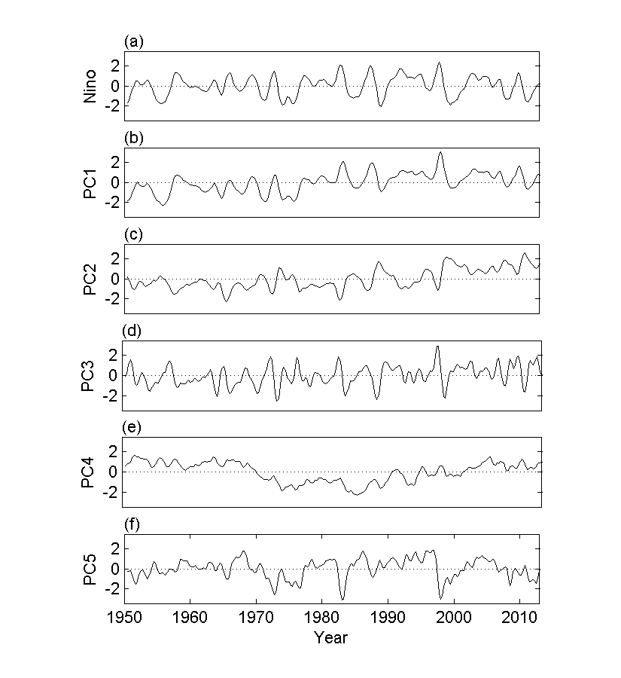

Figure 1. The Nino-3.4 index (ºC) and principal components (PCs) of the first five EEOF modes. The PCs are normalized. They are 19.2, 13.5, 7.6, 4.5, and 3.9% of total variance respectively.

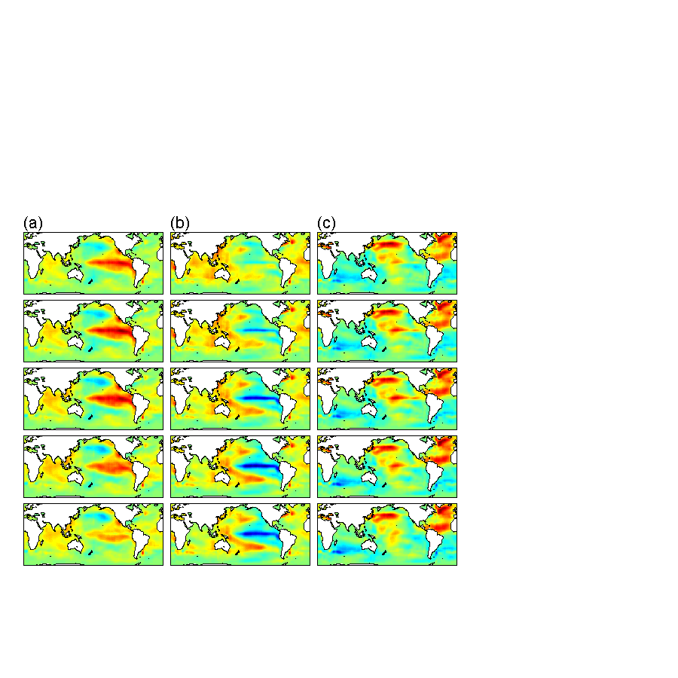

Figure 2. Spatial patterns of the (a) first, (b) second, and (c) fourth EEOF modes. Each mode spans five seasons, and is normalized with respect to the maximum absolute amplitude of the five seasons.

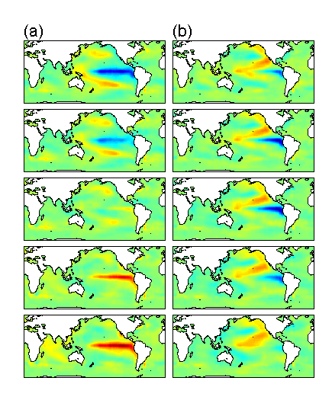

Figure 3. Spatial patterns of the (a) third, (b) fifth EEOF modes. Each mode spans five seasons, and is normalized with respect to the maximum absolute amplitude of the five seasons.

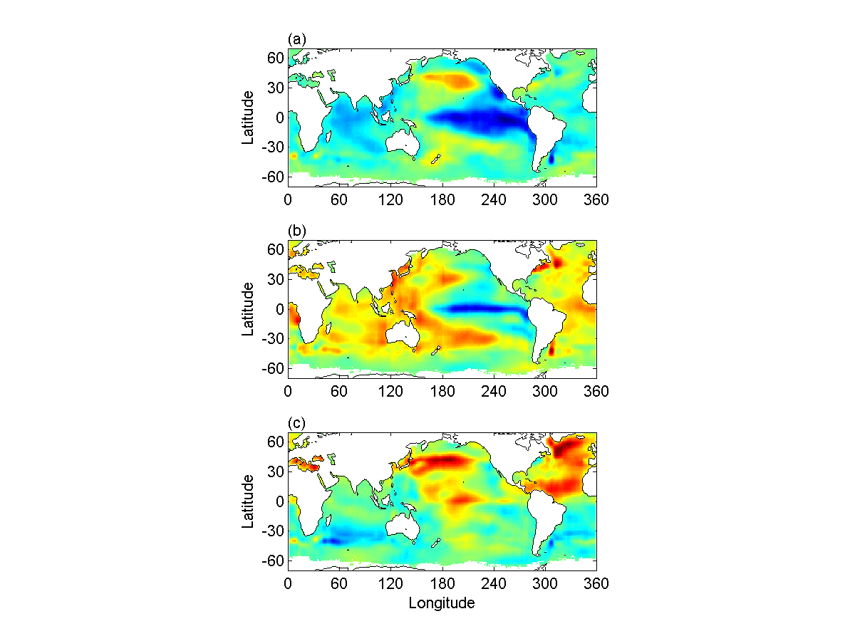

Figure 4. The five-season averaged spatial patterns for the (a) first, (b) second, and (c) fourth EEOF modes. Each mode is normalized.

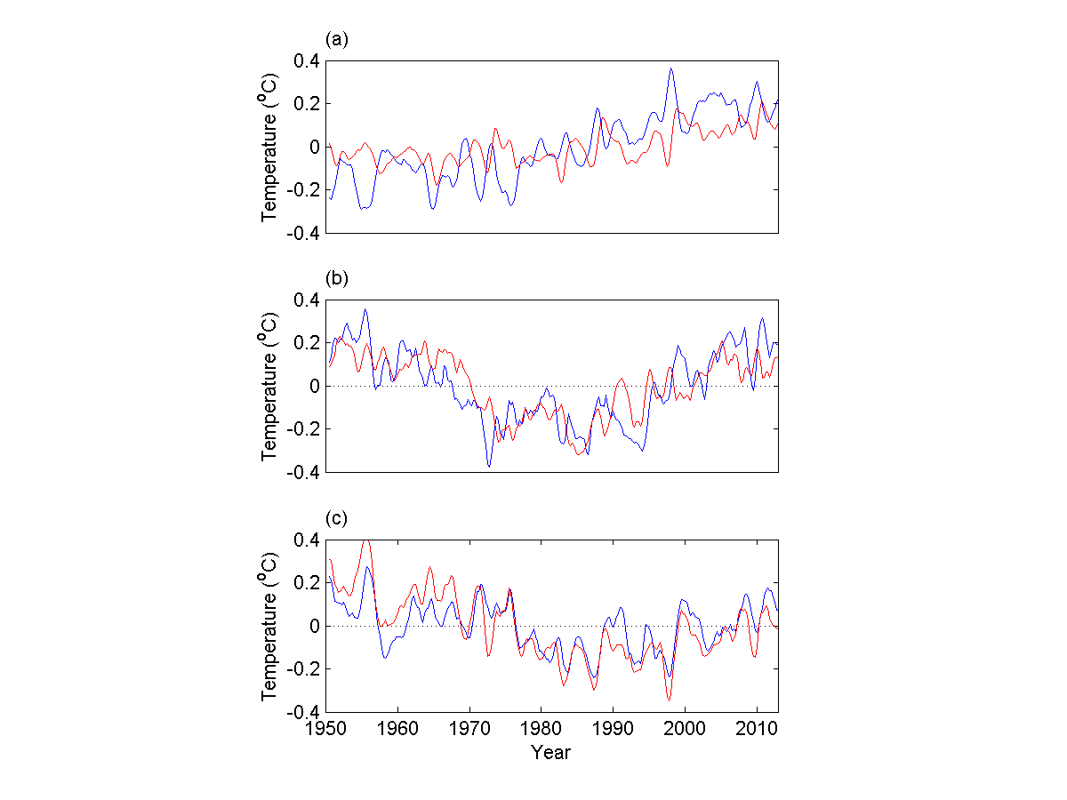

Figure 5. (a) Global mean SST (blue) and second EEOF mode (red); (b) AMO index (blue) and fourth EEOF mode (red); and (c) PDO index (blue) and sum of second and fourth EEOF modes minus global mean (red).

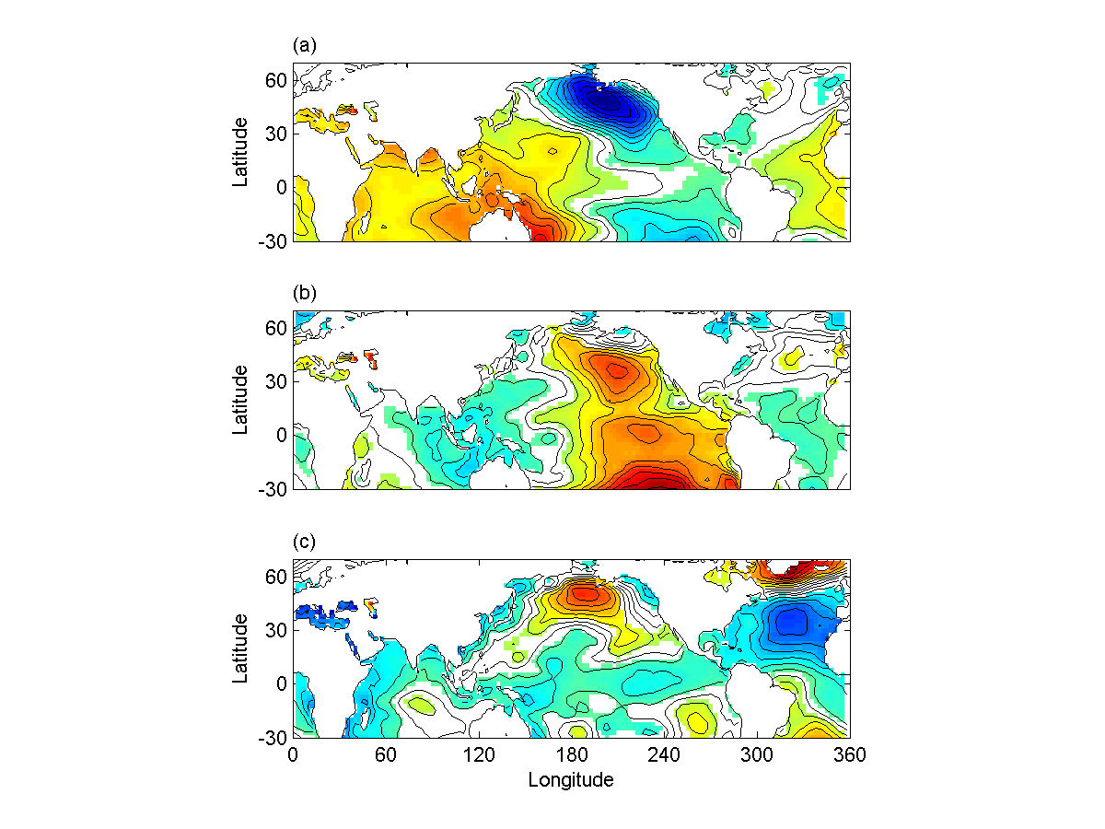
Figure 6. Sea level pressure regressed to the five-season averaged EEOF modes: (a) first, (b) second, and (c) fourth. Each mode is normalized. Contour interval is 0.2. The colored regions are above 95% confidence interval.

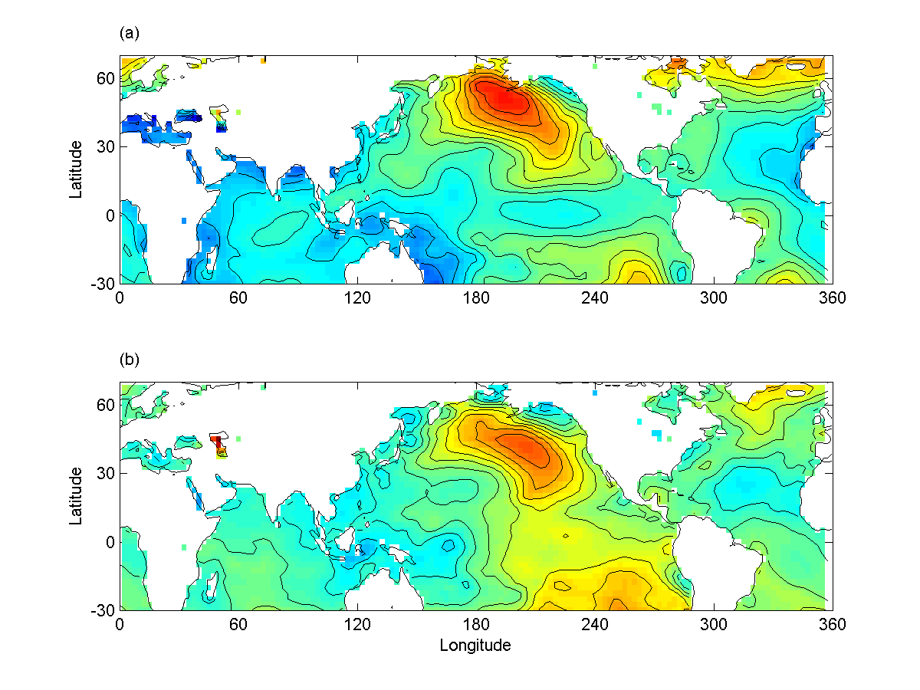

Figure 7. Interdecadal differences of sea level pressure between (a) 1950-1977 and 1977-1999, and (b) 1999-2013 and 1977-1999. Each map is normalized. Contour interval is 0.2.

